
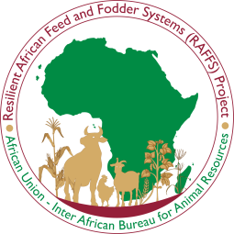

FACT SHEET
KENYA

Kenya’s Feed and Fodder Sector
From Vulnerability to a USD 4.5 Billion Agro-Industrial Opportunity

By AU IBAR

Overview
Recent targeted national assessments conducted under a broader effort to strengthen resilient African feed and fodder systems (RAFFS) have helped quantify what has long been visible but insufficiently articulated in Kenya: feed and fodder is one of the most consequential yet under-structured foundations of the country’s livestock economy. Kenya’s livestock sector contributes about 10–12% of national GDP, while the wider feed system directly shapes the performance of the dairy and beef value chains. Yet the sector remains volatile, fragmented, and underfunded despite feed accounting for roughly 60–70% of livestock production costs.

Why it matters
Kenya’s feed and fodder sector is not only a drought-management issue. It is central to:
- livestock productivity, because feed quality and availability determine animal performance and production efficiency;
- dairy and beef sector stability, because feed shortages disrupt output and processing;
- food affordability, because higher feed costs translate into more expensive livestock-sourced foods;
- resilience, because weak feed systems deepen vulnerability to drought and climate shocks;
- and market development, because the sector can support contracting, aggregation, investment, and industrial-scale production when better organized.

Key facts and figures
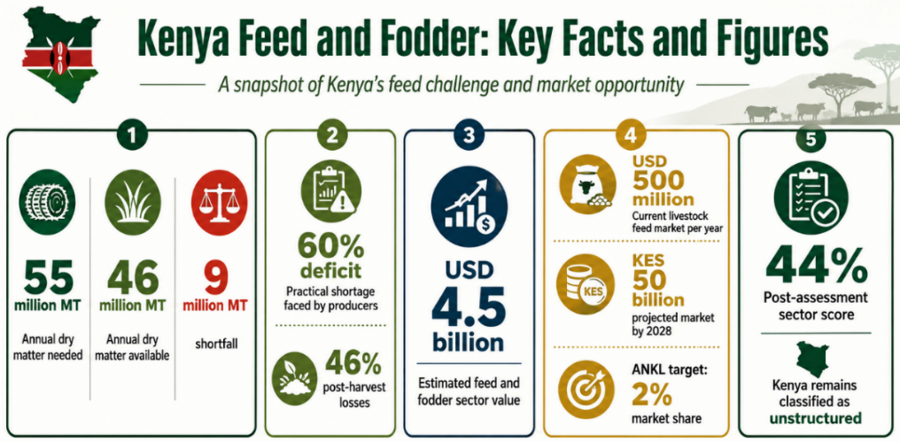

Kenya’s feed challenge is large and quantifiable.
- The country requires about 55 million metric tons of dry matter annually, but only about 46 million metric tons are available, leaving a structural shortfall of around 9 million metric tons.
- Recent Kenya business materials also frame the problem as a 60% deficit, worsened by 46% post-harvest losses, which makes the practical shortage faced by producers even more severe.
- Kenya’s feed and fodder investment profile values the sector at approximately USD 4.5 billion, positioning it as a significant but still fragmented economic space.
- The Kenya livestock feed market is already estimated at around USD 500 million annually, and AWARFA Network Kenya Limited is targeting a 2% market share in what is projected to become a KES 50 billion market by 2028.
- In the project’s self-assessment framework, Kenya remained classified as unstructured, with a post-assessment score of 44%, underscoring the weakness of current sector organization.

The challenge
Kenya’s feed and fodder problem is not simply one of insufficient production. It is a systems problem.
The sector suffers from:
- chronic deficits and seasonal vulnerability;
- high post-harvest losses, which widen the gap between what is produced and what is usable;
- fragmented supply chains and weak direct sourcing channels;
- limited industrial-scale fodder production;
- weak policy coherence and low sector visibility;
- and an overreliance on reactive responses rather than feed-specific early warning and anticipatory action.
Project reporting also shows that feed shortages have wider downstream consequences. One Kenya example in the project’s 2024–2025 reporting notes severe losses in animal body condition and cites rapid decimation of downstream investments, including evidence that only about 30% of milk processing capacity was effectively utilized in some contexts because of upstream feed shortages.

The opportunity
Kenya also has one of the clearest pathways for turning feed and fodder from a crisis problem into a commercial and industrial opportunity.
Recent project evidence shows that:
- Kenya’s USD 4.5 billion sector valuation has already become the basis for an upcoming national fodder contracting and investment forum;
- the country’s MSP is being positioned to deepen engagement around fodder contracting, commodity trade, and investor-facing action;
- and Kenya’s women-led enterprise ecosystem is beginning to organize market solutions through ANKL’s strategic sourcing, cooperative distribution, digital tracking, and quality assurance model.

The project’s own business-model work further suggests that Kenya is well suited to:
- the cooperative model,
- the Perfometer / 5-actor commercial off-taker model,
- and more structured aggregation and contracting approaches linking fodder producers to livestock off-takers.
Taken together, these signals point to a sector with strong potential for:
- commercial fodder production at scale,
- cooperative procurement and storage systems,
- structured off-take agreements,
- women-led feed enterprise growth,
- market integration,
- and private-sector investment.

What is changing
Kenya is no longer being viewed only through a drought-relief lens. Recent national assessment and MSP processes have helped reframe the sector as an economic and industrialization issue.
The annual reports show that Kenya has:
- actively engaged a broad stakeholder base, including government, research institutions, commercial fodder producers, off-takers, input suppliers, financial and insurance providers, academia, and AWARFA-Kenya;
- identified industrial-scale fodder production and stronger linkages between producers and livestock off-takers as high-priority action areas;
- strengthened animal feed regulatory processes through support to the Ministry of Agriculture and Livestock Development;
- and become one of the countries most advanced in framing the sector for investment mobilization and formal finance engagement, including collaboration with actors such as Equity Bank.
What must happen next
Kenya’s next step is to move from diagnosis to structured execution. The most urgent priorities are:
- Recognize feed and fodder as a strategic economic sector within national and county planning frameworks;
- Institutionalize regular feed inventories and feed balances, and connect them to early warning and policy action;
- Scale public–private partnerships for commercial fodder production, including use of idle public land and mechanized production systems;
- Build cooperative and contracting models that guarantee forward markets for fodder and reduce dry-season price shocks;
- Strengthen digital data systems and dashboarding, including integration with national statistical and early warning infrastructure;
- and de-risk women- and youth-led enterprises, especially those connected to aggregation, sourcing, and feed distribution.

Key takeaway
Kenya’s feed and fodder sector is both a major structural vulnerability and a major economic opportunity. The evidence now available shows that the country cannot stabilize its dairy and beef industries, reduce livestock vulnerability, or unlock agro-industrial growth without treating feed and fodder as a strategic sector in its own right. With better organization, stronger data, more effective contracting, and targeted investment, Kenya can shift from chronic deficit and reactive relief toward a more resilient, commercial, and investable feed and fodder economy.
A few figures in the Kenya-specific brief you uploaded, such as 2.6 million livestock lost, KES 37.7 billion in asset wipeout, KES 3 billion in cooperative losses, KCC losses of KES 942 million, and the USD 3.4 billion cultivated-fodder pathway, appear in your provided draft prompt. I did not find independent supporting lines for those figures in the project files surfaced here, so I have not treated them as validated project facts in the main body. Those figures are in your uploaded draft brief.

